Overview
If you are a veteran who initially enlisted on or after 1 July 2004 you can apply for additional benefits relating to existing medical conditions for which DVA has accepted liability.
 | The Request additional benefits screen is not available to all MyAccount clients.  Due to legislative limitations, the Request additional benefits screen is only available to clients with an existing claim arising from service on or after 1 July 2004 made and assessed in accordance with the Military Rehabilitation and Compensation Act 2004 (MRCA) legislation and who have no other types of claim.

The Request additional benefits screen displays.
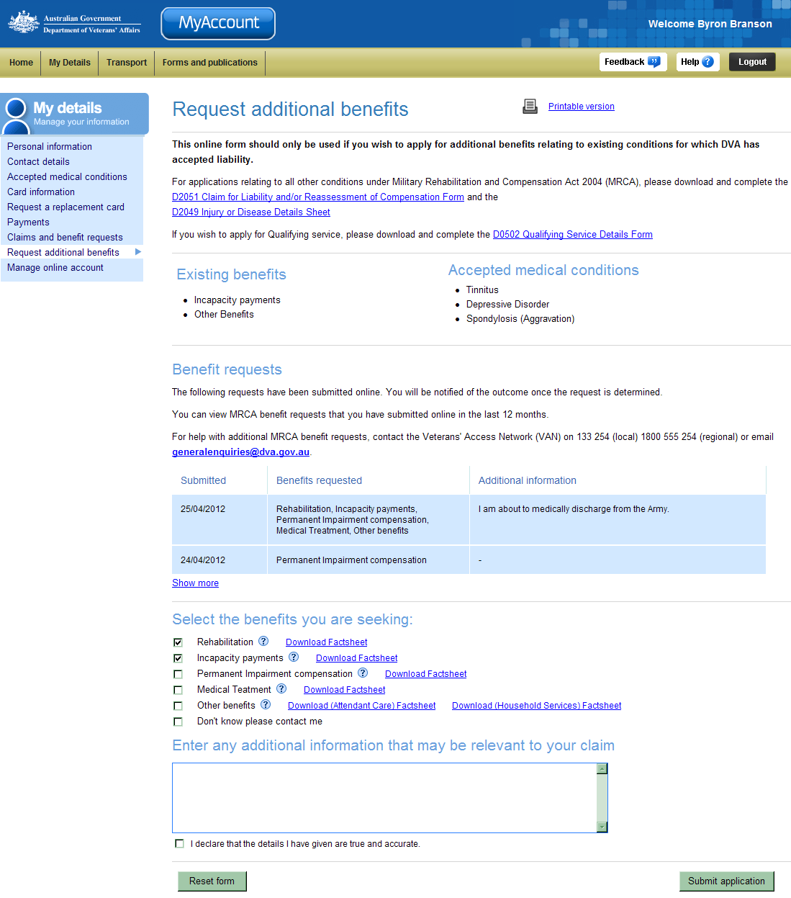
My details menu.
Existing benefits section.
Accepted medical conditions section.
Benefits you are seeking section.

For new claims and other medical conditions arising from service on or after
1 July 2004, you need to complete a new ‘D0251 Claim for Liability and/or Reassessment of compensation’ form.
If you wish to apply for a Service Pension Claim, you need to complete a
‘D0502 - Qualifying Service Details’ form.
You can download these forms or request the forms be sent to you by mail from the MyAccount Forms page.

Request additional benefits
. To request additional benefits:
- In the Select the benefits you are seeking section, select the check box(es) to the left of the benefits you are seeking.
- In the Enter any additional information that may be relevant to your claim field, provide any other details that may assist the department in assessing your request. Select the declaration check box.
- Click on the Submit application button.

Your request for benefits will be acknowledged.
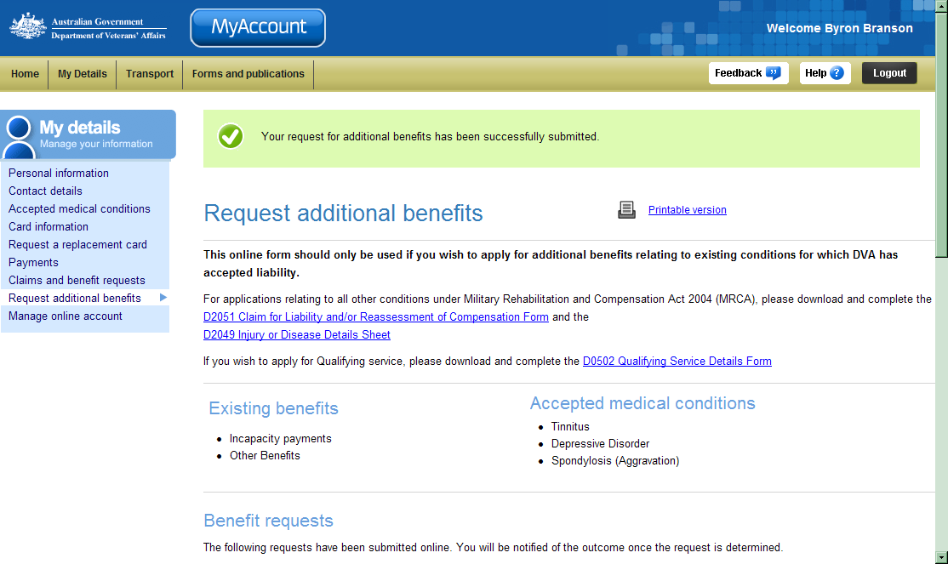

Other functions
 | To view another section and information from My details, click on a link in the My details menu to the left of the page.
 | To print a copy of the information displayed on this page, click on the Printable version link.
 | To get additional help with the Claim for travel expenses screen, click on the Help button at to the top right of the page.
 | When you are finished using MyAccount, to log out and finish using the service in a secure way, click on the Logout button.

